Entry Form
for 2023
Spring Madness
Abstracts Only Exhibition
Gallery 294 Corowa
Opening: Saturday Sept 9 (2 - 4pm)
Exhibition runs: Tues Sept 5 – Fri Sept 29
Number of Entries: ONE per artist
Size restriction: Up to 1.5 metres in any one direction including frame or base
All media both 2D & 3D most welcome but must be original artwork of the artist (no reproductions)
Artworks do not have to be new work but they must not have been exhibited in Gallery 294 before.
Entry Fee: $10
Must be paid with delivery of work to gallery
Delivery of Entries to Gallery 294:
Friday Sept 1 to Sunday Sept 3. Gallery opening hours 10am-4pm (no late entries taken)
Conditions of entry
All works must be new to Gallery 294.
All entries must be ready for display:
Paintings/drawings/photographs etc must have a secure hanging wire/cord/system that is suitable for hanging using gallery ‘hanging hooks’
3D works must have their own display system with them unless they can sit directly onto a gallery plinth
All entries must have a small removable tag on their back: for identification for sales sheet and for payment if the item is sold. This tag should be small enough not to be seen by the public and must include:
- Your initials
- The name of artwork
- The sale price (which must include $25% sales commission)
Wall labels with all details of artist, title of work, price etc. will be provided by Gallery 294
All artists and friends are invited to a FREE opening and social function on Saturday September 9 to be held at Gallery 294 from 2pm – 4pm
Collection of unsold work: Saturday Sept 30 to Sunday Oct 1. Storage is not available after Oct 1.

For further information please contact:
Glenda Mackay on 0409309987 or at glenda.mackay@westnet.net.au
Where is Gallery 294?
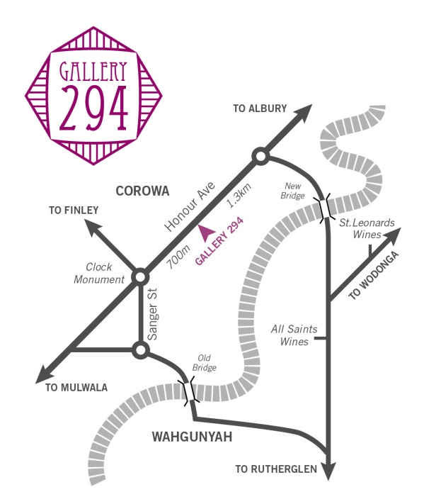
Gallery 294 is located within the Murray Tourism belt of the NSW Riverina District and the Victorian North East Winery District. There are more than 20 wineries and more than 50 accommodation providers within 20 km of the gallery.
Contact Details:
Gallery 294
294 Honour Ave (the Albury Rd)
COROWA
NSW 2646
Phone: 02 6033 5086
www.gallery294.org.
This a Gallery 294 annual event as our aim is to promote artwork and provide a place for artists to sell their work in a gallery setting.
Information required by Gallery 294
- Each artist must fill out this form
- Bring form and $10 entry fee to Gallery 294 between
Friday Sept 1 to Sunday Sept 3
Opening hours 10am-4pm (no late entries taken)

Name of Artist:______________________________
Mobile number: ____________________________
Email Address:______________________________
Title of Work:_______________________________
Sale Price (includes 25% sales commission)_______
Medium used:______________________________

Ready for hanging 2D work must be equal or less than 1.5 metres in any one direction
Ready for display 3D work must be equal or less than 1.5 metres in any one direction including base
Please Note: Gallery 294 pays artist for sales via direct deposit. Contact will be made via phone if these details are required.

