Entry Form
2021
Spring Madness
Abstracts Only Exhibition
Gallery 294 Corowa
Saturday September 4 – Sunday October 17 Exhibition is on display for six weeks
Official Opening and Meet the Artists: Saturday September 4 (2pm – 4pm)
Number of Entries: ONE per artist
Work must be the original artwork of the artist and not have been shown at Gallery 294 before.
Size restriction: up to 2 metres in any one direction including frame or base

All media both 2D & 3D most welcome.
Entry Fee: $10
Must be paid with delivery of work to gallery
Delivery of Entries and Entry forms to Gallery 294:
Thursday August 26 to Monday August 30
Gallery opening hours 10am-4pm (no late entries)
Accidental damage or theft of works on exhibition is not covered by Gallery 294 insurance.
Conditions of entry
All entries must be ready for display:
Paintings/drawings/photographs etc must have a secure hanging wire/cord/system that is suitable for hanging using gallery ‘hanging hooks’
3D works must have their own display system with them unless they can sit directly onto a gallery plinth
All entries must have a small removable tag on their back/bottom: for identification for sales sheet and for payment if the item is sold. This tag should be small enough not to be seen by the public and must include:
- Your initials
- The name of artwork
- The sale price (which must include $25% sales commission)
Wall labels with all details of artist, title of work, price etc. will be provided by Gallery 294
Collection of unsold work: Sunday October 17, - Friday October 22. Note Gallery294 is closed on Wednesday 20. Gallery open 10am – 4pm
Storage is not available after October 20.
For further information please contact: Gallery 294 on 02 6033 5086
Marg Wilmot on 02 6033 2734 or at margaret_wilmot@hotmail.com
Gallery History
Gallery 294 opened May 30. 2008 and is open 6 days per week (Closed Wednesdays) from 10am – 4pm. It is manned by the members of the Co-op.
Where is Gallery 294?
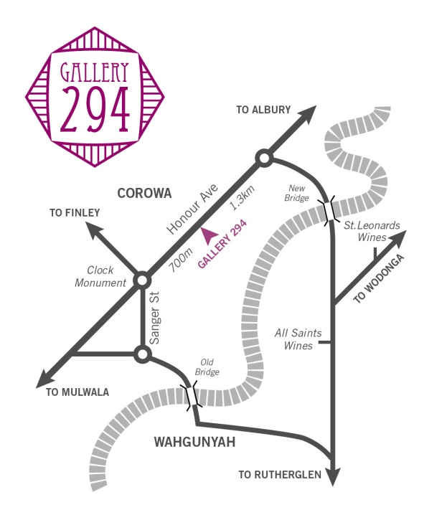
Gallery 294 is located within the Murray Tourism belt of the NSW Riverina District and the Victorian North East Winery District. There are more than 20 wineries and more than 50 accommodation providers within 20ks of the gallery.
Contact Details:
Gallery 294
294 Honour Ave (the Albury Rd)
COROWA
NSW 2646
Phone: 02 6033 5086
www.gallery294.org
Gallery294 has made Spring Madness an annual event as our aim is to promote all forms of art and provide a place for artists to sell their work in a gallery setting.

Information required by Gallery 294
- Each Artist must fill out this form
- Bring form and $10 entry fee to Gallery 294 between
Thursday August 26 to Monday August 30
Opening hours 10am-4pm (no late entries taken)
Name of Artist:______________________________
Contact number: ____________________________
Email address -----------------------------------------------
Title of Work:_______________________________
Sale Price (includes 25% sales commission)_______
Medium used:______________________________
Ready for hanging 2D work must be equal to or less than 2 metres in any one direction including frame.
Ready for display 3D work must be equal to or less than 2 metres in any one direction including base.
Please Note: Gallery 294 pays artist for sales via direct deposit. Contact will be made via phone if these details are required.

